
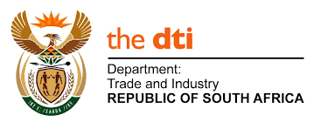

Foundry Survey Questionnaire
This survey is being undertaken by the National Foundry Technology Network (NFTN), which is a support initiative for the foundry industry funded by the Department of Trade and Industry (the dti). The mandate of the NFTN is to improve the competitiveness of the local foundry industry, especially distressed foundries.
The study aims to provide an informed overview of the foundry industry in South Africa that will enable the NFTN to identify measures that can be implemented to facilitate the recovery of the industry and assist foundries to become self-sustainable.
The purpose of this questionnaire survey is to better understand the current state of energy efficiency and environmental compliance across all foundries in South Africa, in order to development a program to improve both these aspects for these foundries.
We anticipate that some of the information contained in this questionnaire could take some time to collate and we offer you our assistance in collating the data. If we have, in your opinion, omitted to ask information that you consider relevant to the survey, please discuss this with the CSIR survey team.

___________________________________________________________________
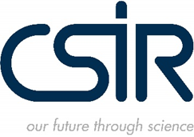


SECTION 1: GENERAL BUSINESS AND PLANT OPERATIONS INFORMATION
- Please complete all questions in full.
- Where needed, please select the applicable option/s with an ‘X’.
Foundry Name:
Foundry Contact Person:
- Name:
- Position:
- Telephone:
- Email:
Foundry Location:
- Town:
- Province:
- GPS coordinates (if available): |  |  | South:  East:
Year the foundry was established / first started operations:
Ownership type (legal entity):
Number of years in business under current ownership:
Installed Melting Capacity (tonnes):
Feedstock (please select): |  |  | Foundry type (please select):
- Virgin metals |  |  | - Jobbing
- Scrap metals (raw) |  |  | - Production
- Scrap metals (cleaned) |  |  | - Jobbing / Production
Metal type (please select):
- Ferrous |  |  | - Non-ferrous
Furnace type (please select):
- Crucible |  |  | - Blast
- Cupola |  |  | - Electric Arc (EAF)
- Electric Induction (EIF) |  |  | - Combustion-based HFO/NG
Number of furnaces: |  |  | Furnace sizes:
Annual production tonnage per metal type:
Average monthly tonnage sold per metal type:
Primary moulding process (please select): |  |  | - Low Pressure Die Casting
- Sand Casting |  |  | - Gravity Die Casting
- Investment Casting |  |  | - High Pressure Casting
Other foundry processes (please select):
- Melting |  |  | - Pouring
- Pattern-making |  |  | - Degassing
- Mould-making |  |  | - Ejection
- Fettling |  |  | - Shakeout
- Inspection |  |  | - Heat treating
- Surface cleaning |  |  | - Finishing
Number of melting shifts per day: |  |  | Number of operating hours per month:
Type of finished products: |  |  | Typical customers:
Type of water source at foundry:
- Municipal supply |  |  | - Surface water (e.g. river or spring)
- Groundwater (boreholes) |  |  | - Recycled / Wastewater
Average monthly water consumption (litres):
Employment (number of jobs):
- Number of male employees |  |  | - Number of female employees
- Number of permanent staff |  |  | - Number of contract (part-time) staff
What training and skills development are required to operate the foundry?
What type of skills or trades is currently available in the foundry?
What percentage of your management / supervisory team is tertiary graduates?

Are there any skills shortages at the moment? If yes, please specify.

SECTION 2: ENERGY USE INFORMATION
- Please complete all questions in full.
- Where needed, please select the applicable option/s with an ‘X’.
Main energy source at foundry:
Energy Bills available: Yes / No
Please provide copies of last 6 months
Total installed electrical load (MVA):
Maximum operational load utilisation (MVA) of the site:
During winter :
During summer:
Average monthly energy consumption:
Average monthly energy cost (Rands):
Energy Supplier:
Current Tariff (Rands / kWhour):
Current power factor:
Other energy-use operations at the foundry (please select):
- Steam boilers and distribution systems
- Motors
- Pumps
- Heating, ventilation and air conditioning
- Lighting
- Compressors
Last Energy Assessment / Audit Date:

SECTION 3: ENVIRONMENTAL INFORMATION
- Please complete all questions in full.
- Where needed, please select the applicable option/s with an ‘X’.
3.1 Environmental Authorisation (in terms of the National Environmental Management Act, NEMA):
Was the foundry established before 1997? |  |  | Yes | No
- If yes, was and environmental impact assessment (EIA) conducted? |  |  | Yes | No
- If yes, was a positive Record of Decision (RoD) or Environmental Authorisation (EA) obtained? If yes, please provide a copy. |  |  | Yes | No
If the foundry was established pre-1997, was it expanded after 1997? |  |  | Yes | No
- If yes, did such expansion or changes result in the need for a permit or licence or an amended permit or licence in terms of national or provincial legislation governing the release of atmospheric emissions or pollution? |  |  | Yes | No
Was the foundry established after 1997? |  |  | Yes | No
- If yes, was and environmental impact assessment (EIA) conducted? |  |  | Yes | No
- If yes, was a positive Record of Decision (RoD) or Environmental Authorisation (EA) obtained? If yes, please provide a copy. |  |  | Yes | No
3.2 Ambient Air Quality (in terms of the National Environmental Management: Air Quality Act, NEM:AQA):
What are the main atmospheric emissions at your foundry (please select)?
- Particulate matter
- Sulphur dioxide, SO₂ (“soxes”)
- Oxides of nitrogen, NO_{x} (“noxes”)
- Other (please specify)
Does your foundry have an Atmospheric Emissions License (AEL)?  If yes, please provide a copy. |  |  | Yes | No
If no, does your foundry trigger the need for an Atmospheric Emissions License? |  |  | Yes | No
If yes, are you currently in a process to obtain an Atmospheric Emissions License? |  |  | Yes | No
3.3 ISO 14001 Environmental Certification
Does your foundry have ISO 14001 Environmental Certification?  If yes, please provide a copy of the certificate. |  |  | Yes | No
If no, are you currently in a process to obtain ISO 14001 Environmental Certification? |  |  | Yes | No
When last was your foundry audited for environmental compliance?
Please provide date.

Appendices to Environmental section for clarification
- Environmental Authorisation (in terms of NEMA and the EIA Regulations)
The following listed activities may trigger the need for an Environmental Authorisation:
- LN 1, activity 12. The development of - ….. (x) buildings exceeding 100 square metres in size; .. (xii) infrastructure or structures with physical footprint of 100 square metres or more, … where such development occurs (a) within a watercourse, (b) in front of a development setback line; (c ) if no development setback exists, within 32m of a watercourse…
- LN 1, activity 14. The development of facilities or infrastructure, for the storage, or for the storage and handling, of a dangerous good, where such storage occurs in containers with a combined capacity of 80 cubic metres or more but not exceeding 500 cubic metres.
- LN 1, activity 27. The clearance of an area of 1 hectares or more, but less than 20 hectares of indigenous vegetation.
- LN 1, activity 28. Residential, mixed, retail, commercial, industrial or institutional developments where such land was used for agriculture or afforestation on or after 01 April 1998 and where such development: (i) will occur inside an urban area, where the total land to be developed is bigger than 5 hectares; or (ii) will occur outside an urban area, where the total land to be developed is bigger than 1 hectare;
- LN 1, activity 34. The expansion or changes to existing facilities for any process or activity where such expansion or changes will result in the need for a permit or licence or an amended permit or licence in terms of national or provincial legislation governing the release of emissions or pollution
- LN 2, activity 6 – development of a facility that requires a license or permit for generation of release of emissions, pollution or effluent.
- LN 2, activity 15 – clearing more than 20 hectares of indigenous vegetation.
- LN 3 – this Listing Notices specifies the need for an Environmental Authorisation based on the scale of project impact on various receiving environments, such as Critical Biodiversity Areas.

- Ambient air quality
The AEL requirements are specified in NEM: AQA of 2004 and listed activities contained in GNR 893 of 22 November 2013.
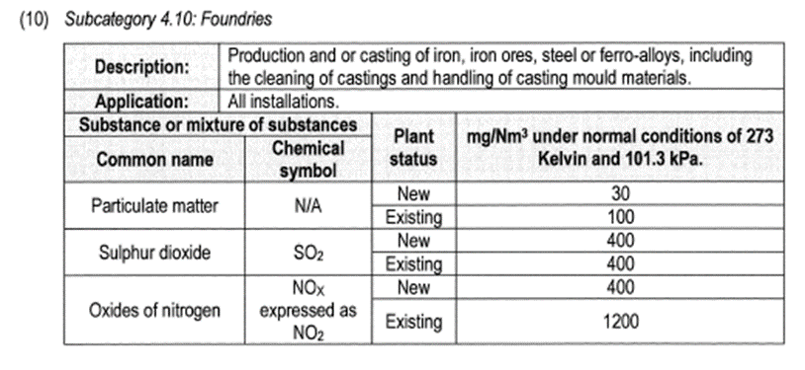
Section 4: Economic Information
- Please complete all questions in full.
- Where needed, please select the applicable option/s with an ‘X’.
What is your foundry’s annual turnover (please select)?
- Less than R 1 million
- R 1.1 – R 3 million
- R 3.1 – R 5 million
- R 5 – R 10 million
- More than R 10 million
Does your foundry export? |  |  |  |  |  | Yes | No
If yes, what share (%) of your output is exported?
Does your foundry have a contract with an OEM? |  |  |  |  |  | Yes | No
What percentage (%) of your business is jobbing?
What is the average age of your capital stock (please select)?
- Less than 6 years
- 7-12 years
- 13-18 years
- Older than 18 years
How much capital (in Rand terms) have you had to invest over the past 5 years in response to increasing energy costs? Please specify the type of investment.
How much capital (in Rand terms) have you had to invest over the past 5 years in response to environmental compliance? Please specify the type of investment.
Have other capital investment plans been delayed or negatively impacted by investments due to increasing energy costs and/or environmental compliance? If yes, please specify.
How have you financed your capital investments over the past 5 years (please select)?
- Retained earnings
- Share issue
- Borrowing
- Government support package
- Other (please specify)
What percentage of your operating costs is attributable to energy inputs and how has it changed over time? Please select the specific years.
 | Current year |  | 5 years ago |  | 10 years ago
Less than 5%
5 - 8%
9 - 12%
13 - 16%
17 - 20%
21 - 30%
31 - 40%
41 - 50%
More than 50%
What is the breakdown of your operating costs (in percentages)?
- Energy |  |  |  |  |  | %
- Materials and scrap |  |  |  |  |  | %
- Labour |  |  |  |  |  | %
- Maintenance |  |  |  |  |  | %
- Sand and Resins |  |  |  |  |  | %
- Other (please specify) |  |  |  |  |  | %
How have you predominantly dealt with the increase in energy and compliance costs over the past 5 years? Please explain.
Passed cost increase onto customer and retained customer
Passed cost onto customer and lost customer
Reduced profit margins
Passed some of the cost onto the customer and took some decrease in margin. Please specify ratio (e.g. 70% of cost increase onto customer and 30% taken as decrease in margin).
Other
What has happened to your order book in the past 5 years? Please select.
No change:
Increased: |  |  |  | 1 - 8%
 |  |  |  | 9 - 17%
 |  |  |  | >17%
Decreased: |  |  |  | 1 - 8%
 |  |  |  | 9 - 17%
 |  |  |  | >17%
Other (please specify):

